Se11. Utilities->Other Dictionary Objects

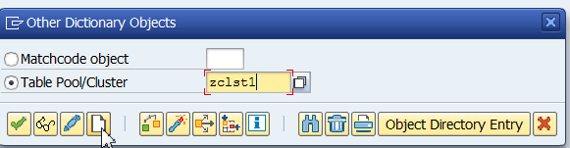

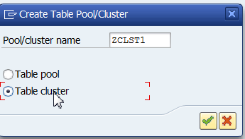

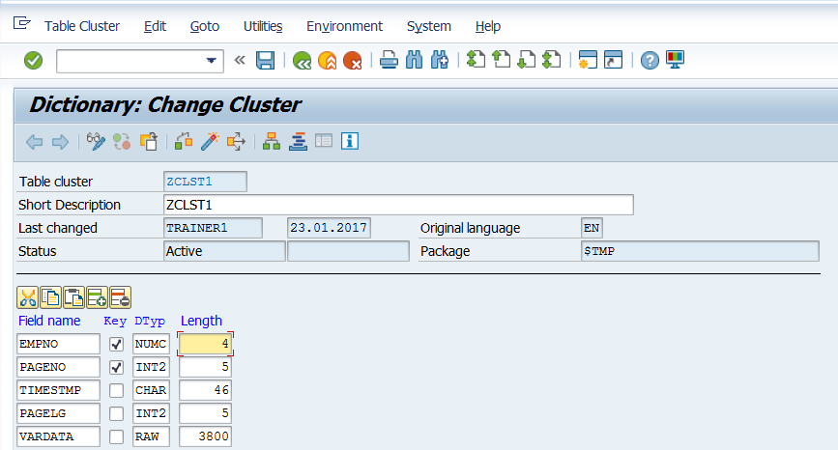

Change Key from Varkey Length 110 to Numc 4. This is because the ZVKEMP table that we are creating later has that key.

Save and Activate.

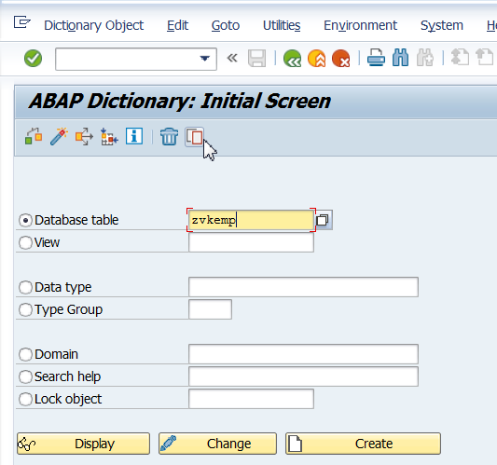

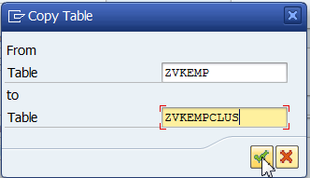

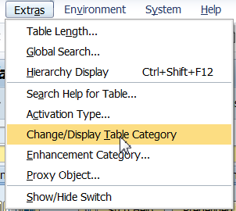

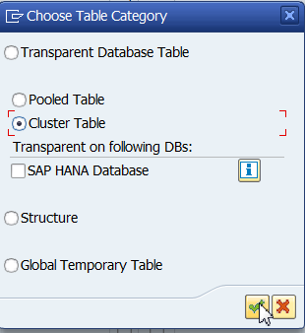

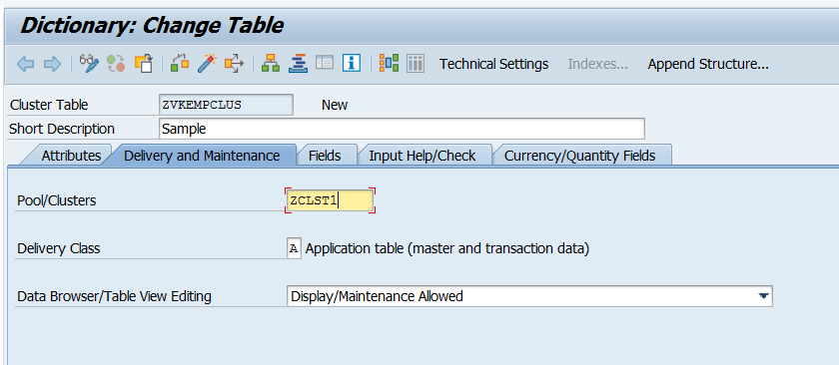

A pool table can be created in the same way. No common key is required for that.

This way we can have many tables belonging to the same cluster/pool.

Activate the table.